MySQL Create Database

A database is used to store the collection of records in an organized form.
It allows us to hold the data into tables, rows, columns, and indexes to find the relevant information.

It allows us to create a database mainly in two ways:

1) MySQL Command Line Client
2) MySQL Workbench

1) MySQL Command Line Client :
We can create a new database in MySQL by using the CREATE DATABASE statement with the below syntax:

CREATE DATABASE [IF NOT EXISTS] database_name
[CHARACTER SET charset_name]
[COLLATE collation_name];

Example :
mysql> CREATE DATABASE employeesdb;

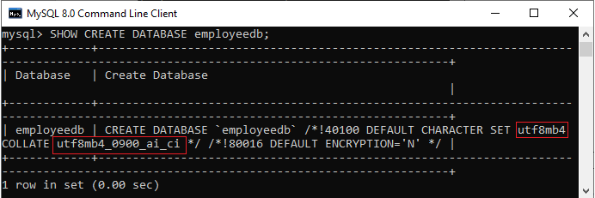

mysql> SHOW DATABASES;

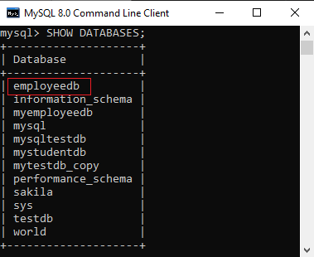

we can use the below command to access the database that enables us to create a table and other database objects.

mysql> USE emplyeedb;

MySQL Workbench :

It is a visual database designing or GUI tool used to work with database architects, developers, and Database Administrators. This visual tool supports SQL development, data modeling, data migration, and comprehensive administration tools for server configuration, user administration, backup, and many more. It allows us to create new physical data models, E-R diagrams, and SQL development (run queries, etc.).

